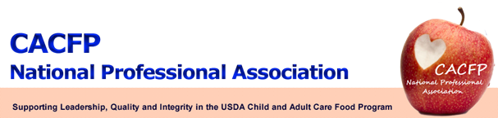

September 2012 Message of the Month

Election Results!!
Please join us in congratulating and welcoming our newly elected executive board members and regional representatives!
Executive Board
President-elect: Ann McCormack – Missouri
Treasurer: Connie Bell – New Mexico

Regional Representative
Northeast Regional Representative Deborah Langley – New York
Mid-Atlantic Regional Representative Norma Birckhead – District of Columbia
Midwest Regional Representative Thomas Saunders - Ohio
Mountain Plains Regional Representative Robin Holz – Iowa

New President
Lynn Torpy – Colorado

A special thanks to our outgoing President, Ellen Farrell and regional representatives: Linda St. Clair, Louise Frey, Benedict Onye, Mary Lou Davis and Diane Hogan as immediate past president for your years of service and valuable contribution during your tenure on the board. Ellen will remain on the board as Past-President but we wish the others the best and will definitely keep you in mind for any interesting work that comes to the attention of the board during the next year.

FNS Update

- Memo: Streamlining SFA Participation in CACFP At-Risk Afterschool Program to be released later this month.

- Proposed CACFP Meal Patterns: The CACFP Meal Pattern proposed rule is in clearance; has to be reviewed by OMB which can take up to 90 days; no date for release.

- Issue: States must allow unaffiliated centers to be sponsored; this is a program option and is allowable.

- Adult Day Care Handbook: In progress; may ask Florida and Texas to review before releasing due to a larger number of adult day care centers in their states.

- Farm Bill – if no action: clause to extend programs; WIC and SNAP will have across the board cuts

Workgroup Update

- CACFP Technical Assistance Workgroup - Sandra Rhoades, Director CACFP Homes Administration and Obesity Prevention Units, New York State Department of Health will serve as the CACFP NPA representative.

- Paper Work Reduction Workgroup – Diane Hogan, Ellen Farrell, and Benedict Onye will serve as CACFP NPA representatives.

- Sponsor’s Consortium Workgroup – Lynn Torpy

Website

Continue to check the website at http://www.cacfpnpa.org for the most up-to-date information and minutes from the monthly meetings.

